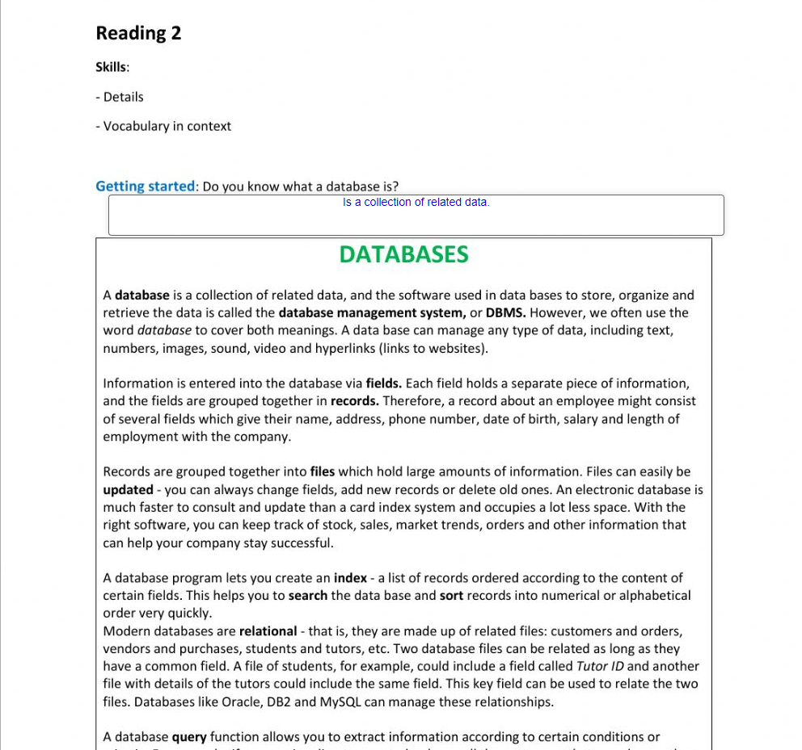

Don Bosco School

Cristian Omar Pineda Campos #11 2C

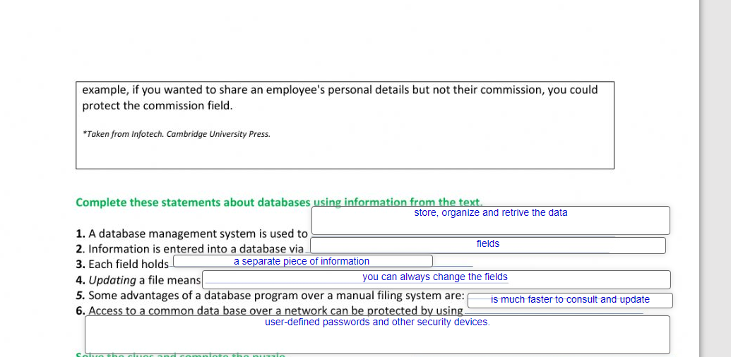

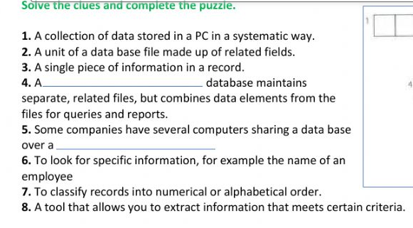

NETWORK

RELATIONAL

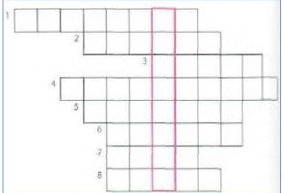

Y

R

E

U

Q

T

R

O

S

H

C

R

A

E

S

K

R

O

W

T

E

N

L

A

N

O

I

T

A

L

E

R

S

E

L

I

F

D

R

O

C

E

R

E

S

A

B

A

T

A

D

